Debate IQ
SUBMITTED BY

Vidit Srivastava(RA2511026011581)
Rudransh Rajvanshi(RA2511026011346)

UNDER THE GUIDANCE OF

Sukumar R

21CSC101T – OBJECT ORIENTED DESIGN AND PROGRAMMING


DEPARTMENT OF COMPUTATIONAL INTELLIGENCE
SRM INSTITUTE OF SCIENCE AND TECHNOLOGY
KATTANKULATHUR- 603 203
MAY 2026

MARK RUBRICS
APPLICATION DESIGN (3)
UML DIAGRAMS (3)
DEMONSTRATION (2)
PRESENTATION AND DOCUMENTATION (2)
TOTAL (10)

TABLE OF CONTENTS
Cover Page 1
1. Abstract 3
2. Introduction 4
3. OOP Concepts Used 5
4. System Analysis 7
5. System Design Using UML 8
6. Implementation Details 11
7. Output Screens / Results 13
8. Testing 14
9. Features & Enhancements 15
10. Conclusion 16
11. References 16

1. Abstract
DebateIQ is a console-based application built in C++ that simulates a structured two-person debate and scores each argument objectively. Two participants — one arguing FOR and one AGAINST a chosen topic — take turns presenting arguments across multiple rounds. Each argument is rated on three parameters: Logic, Evidence, and Clarity, each scored out of 10, giving a maximum of 30 points per argument. At the end of all rounds, cumulative scores are compared and a winner is declared along with an overall debate quality grade.

The application is built entirely using Object-Oriented Programming (OOP) principles in C++ and demonstrates core OOPS concepts including classes and objects, inheritance, polymorphism, abstraction, encapsulation, friend functions, operator overloading, and parameterized constructors. The system provides a clean, interactive terminal interface with color-coded output for better readability.
2. Introduction
2.1 Background
Debates are a core part of academic and professional life, yet evaluating argument quality in a structured, unbiased way is difficult without a systematic scoring framework. Traditional debates are judged subjectively. DebateIQ addresses this by providing a rule-based scoring engine that quantifies argument quality across multiple dimensions.
2.2 Need for the System
There is no simple, accessible tool that allows students or participants to conduct a scored debate session on a computer without requiring internet or complex software. DebateIQ fills this gap with a self-contained C++ application.
2.3 Objective
- Simulate a structured two-participant debate session
- Score arguments objectively on Logic, Evidence, and Clarity
- Declare a winner based on cumulative scores
- Demonstrate all major OOP concepts in a single, practical application
2.4 Scope
The application handles one debate session per run. It supports 1 to 5 rounds, accepts text-based arguments from two debaters (FOR and AGAINST), allows a moderator to manage the session, and produces a detailed results summary at the end.
3. OOP Concepts Used
3.1 Classes and Objects
The application is organized into 6 classes, each representing a real-world entity in a debate:

Class | Role
Score | Stores and calculates argument scores (logic, evidence, clarity)
Argument | Represents a single argument with its content, side, and score
User | Abstract base class for all participants
Debater | A participant who makes arguments; inherits from User
Moderator | Manages rounds and warnings; inherits from User
Debate | Orchestrates the entire session, rounds, and result declaration

3.2 Encapsulation
All class member variables are declared private. Access is provided only through public getter and setter methods, protecting internal data from direct modification.
class Score {
private:
int logic;
int evidence;
int clarity;
public:
void setLogic(int l) { logic = l; }
int getLogic() const { return logic; }
};

3.3 Inheritance
Both Debater and Moderator inherit from the abstract base class User. This allows shared properties (name, userID) and behaviors (getName, getID) to be defined once in the base class and reused.
class Debater : public User { ... };
class Moderator : public User { ... };

3.4 Polymorphism
The base class User declares addPoints() as a virtual function. Debater overrides it to update the total score and print a colored message. This is runtime polymorphism. Additionally, displayRole() is a pure virtual function, overridden in both Debater and Moderator with their specific output.
// Base class
virtual void addPoints(int pts) { ... }

// Debater overrides it
void addPoints(int pts) override {
totalScore += pts;
cout << "+" << pts << " pts added to " << getName();
}

3.5 Abstraction
User is an abstract class because it contains a pure virtual function displayRole(). This means a User object cannot be created directly. Concrete subclasses (Debater, Moderator) must implement it. This enforces a contract: every User in the system must have a defined role.
class User {
public:
virtual void displayRole() const = 0; // pure virtual
};

3.6 Friend Function
The function compareDebaters() is declared as a friend of the Debater class. This allows it to directly access private members (totalScore and side) from outside the class, demonstrating the friend function concept.
class Debater : public User {
friend void compareDebaters(const Debater& a, const Debater& b);
...
};

void compareDebaters(const Debater& a, const Debater& b) {
cout << a.totalScore; // accesses private member
}

3.7 Operator Overloading
The less-than operator (<) is overloaded in the Score class to allow direct comparison of two Score objects based on their calculated total.
bool operator<(const Score& other) const {
return this->calculate() < other.calculate();
}

3.8 Constructors
Every class uses parameterized constructors to initialize all member variables at the time of object creation, ensuring no object exists in an undefined state.
Debater(const string& name, int id, const string& side)
: User(name, id), totalScore(0), side(side), argCount(0) {}
4. System Analysis
4.1 Existing System
Currently, debates in academic settings are evaluated manually by a panel of judges who assign scores based on personal impression. There is no standardized digital tool that a student can run locally to conduct and score a debate.
4.2 Limitations of Existing System
- Evaluation is subjective and inconsistent across judges
- No permanent record of argument content or scores
- Cannot be run independently without a panel of judges
- No separation of scoring dimensions (logic vs. evidence vs. clarity)
4.3 Proposed System — DebateIQ
DebateIQ provides a structured, rule-based scoring system with the following advantages:
- Fully interactive, runs on any system with a C++ compiler
- Scores every argument across three independent dimensions
- Maintains a full argument log for both debaters
- Provides a final comparison and debate quality grade
- Built with clean OOP architecture — easy to extend
5. System Design Using UML
5.1 Use Case Diagram
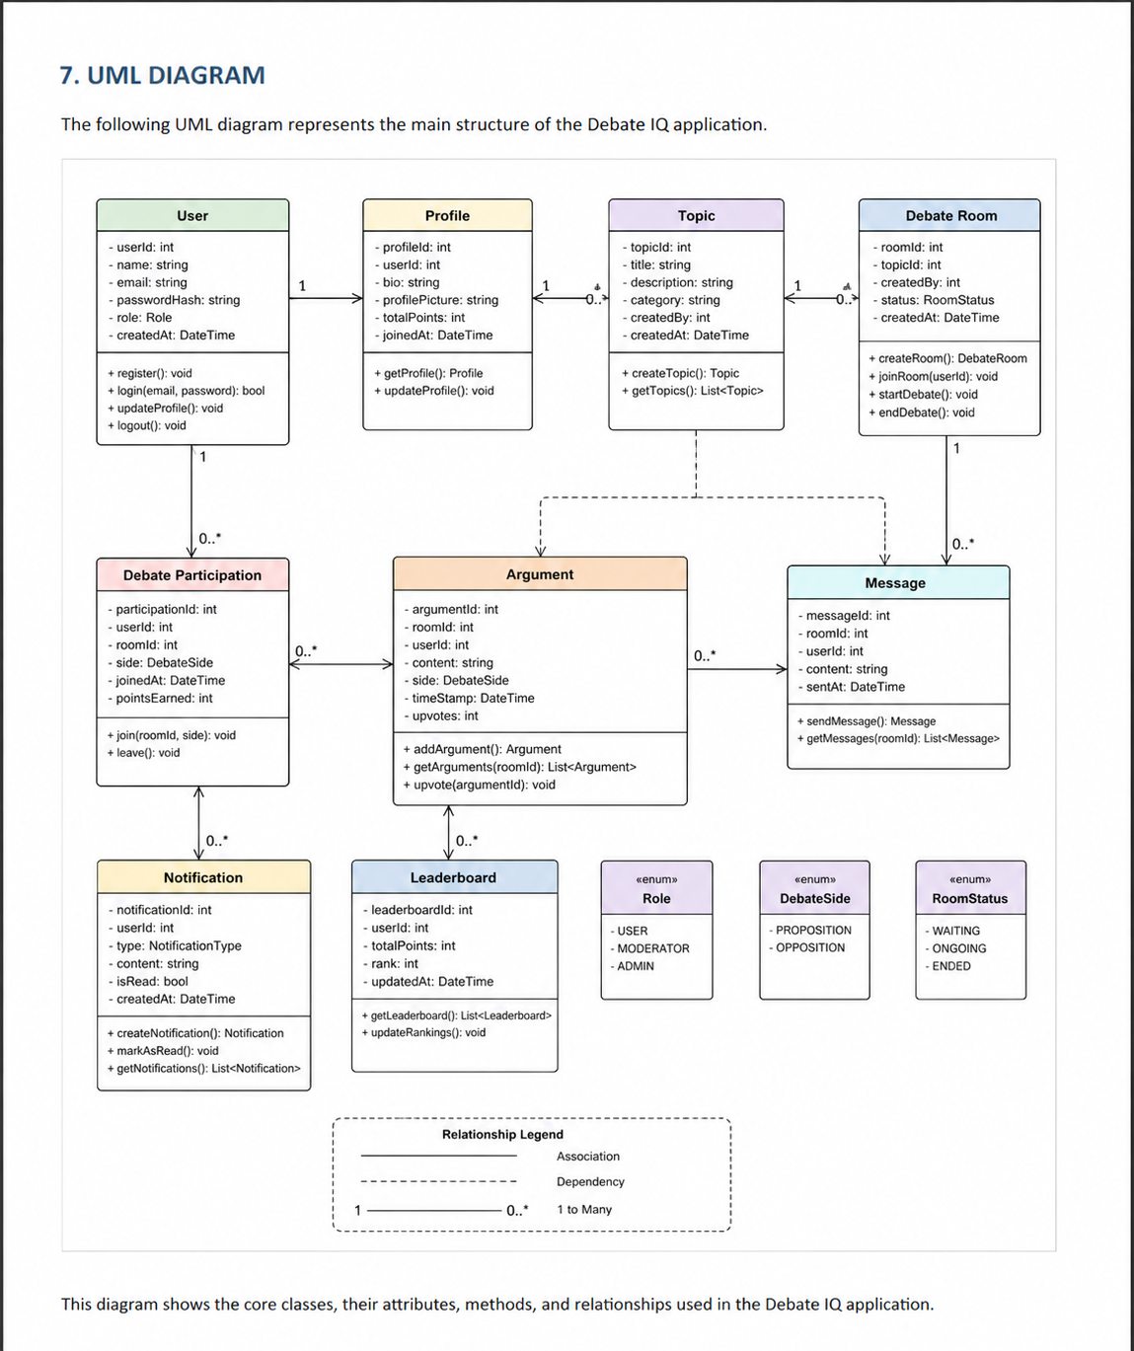

5.2 Class Diagram
The class diagram shows 6 classes with the following relationships:
- User (abstract) is the base class for Debater and Moderator (Inheritance)
- Debater contains a vector of Argument objects (Association)
- Argument contains a Score object (Composition)
- Debate holds pointers to two Debater objects and one Moderator (Aggregation)

Refer to the UML diagram generated separately using Draw.io / StarUML. Key class details:

Class | Key Attributes | Key Methods
User | name: string, userID: int | getName(), getID(), displayRole() [pure virtual]
Debater | totalScore: int, side: string, argCount: int | addPoints(), addArgument(), displaySummary()
Moderator | warningsGiven: int, roundsManaged: int | issueWarning(), advanceRound()
Argument | content: string, side: string, evaluated: bool | setScores(), display(), getScore()
Score | logic: int, evidence: int, clarity: int | calculate(), display(), operator<
Debate | topic: string, currentRound: int, maxRounds: int | start(), declareWinner()

5.3 Sequence Diagram
The sequence of execution for one debate round is as follows:
- main() creates Debater A, Debater B, Moderator, and Debate objects
- Debate::start() is called — displays header, calls displayRole() on all participants
- For each round: Debate calls evaluateArgument() for side FOR — user enters argument and scores
- Argument object is created, setScores() is called, Argument is passed to Debater::addArgument()
- Debater::addPoints() is called with the argument's total score
- Same process repeats for side AGAINST
- After all rounds, Debate::declareWinner() calls compareDebaters() (friend function) and prints results

5.4 Activity Diagram
The main workflow of DebateIQ:
- Start → Show Menu → User selects Start New Debate
- Enter topic, debater names, moderator name, number of rounds
- Round loop begins → Debater A enters argument → Scored → Debater B enters argument → Scored
- If more rounds remain: Moderator advances round → Loop continues
- After final round: Display summaries → Compare scores → Declare winner → Grade debate quality
- Return to menu → User selects Exit → End
6. Implementation Details
6.1 Technology Stack
- Programming Language: C++ (Standard: C++17)
- Compiler: g++ (GCC)
- IDE: Any (VS Code, Code::Blocks, Dev-C++, or terminal)
- Libraries: <iostream>, <string>, <vector>, <limits> (all standard library)

6.2 Module Description
The application is logically divided into the following modules:

Module | Description
Score Module | Score class handles storage and calculation of logic, evidence, and clarity scores. Operator overloading allows score comparison.
Argument Module | Argument class stores the debate text, its side (FOR/AGAINST), and an embedded Score object. Provides setScores() and display().
User Module | Abstract User class defines the base interface. Debater and Moderator extend it with specialized behavior.
Debate Engine | Debate class manages the full session: setup, round loop, argument collection, and winner declaration.
UI / Input Module | printHeader(), printLine(), getStringInput(), getIntInput() helpers manage all terminal I/O with ANSI color formatting.

6.3 Key Code Snippets
Score calculation with clamped minimum:
int calculate() const {
int total = logic + evidence + clarity;
return max(0, total);
}

Polymorphic addPoints override in Debater:
void addPoints(int pts) override {
totalScore += pts;
cout << "+" << pts << " pts -> " << getName() << "\n";
}

Winner declaration logic:
if (scoreA > scoreB)
cout << "WINNER: " << debaterA->getName();
else if (scoreB > scoreA)
cout << "WINNER: " << debaterB->getName();
else
cout << "RESULT: It's a TIE!";
7. Output Screens / Results
The following describes the program execution flow with sample input and output:

7.1 Main Menu
=======================================================
DebateIQ: Argument Strength Scorer
=======================================================

1. Start a New Debate
2. Exit

Choice: 1

7.2 Setup Screen
Enter debate topic: Should AI replace human jobs?
Debater 1 (FOR side) Name: Alex
Debater 2 (AGAINST side) Name: Sara
Moderator name: Prof. Rajan
Number of rounds (1-5): 2

7.3 Round Execution
ROUND 1 of 2
>> Alex's turn (FOR)
Enter argument: AI handles repetitive tasks more efficiently.
Logic score (1-10): 8
Evidence score (1-10): 7
Clarity score (1-10): 9
+24 pts added to Alex

7.4 Final Results
Debater: Alex (FOR)
Arguments made: 2
Total score: 94

Debater: Sara (AGAINST)
Arguments made: 2
Total score: 81

WINNER: Alex [FOR] with 94 points!
Debate Quality: Excellent
8. Testing
The following test cases were used to verify correct behaviour:

# | Test Case | Input | Expected Output | Result
1 | Normal debate, FOR wins | Alex: 9,9,9 / Sara: 5,5,5 (1 round) | WINNER: Alex | Pass
2 | Tie scenario | Both debaters: 7,7,7 each round | RESULT: It's a TIE! | Pass
3 | AGAINST wins | Sara scores higher every round | WINNER: Sara [AGAINST] | Pass
4 | Score clamping | Input score > 10 (e.g. 15) | Clamped to 10 automatically | Pass
5 | Invalid menu input | Enter 'abc' or 9 at menu | Error message, re-prompt | Pass
6 | Maximum rounds | 5 rounds, alternate scoring | Correct cumulative totals | Pass
7 | Debate quality grade | Combined score >= 100 | Output: Excellent | Pass
9. Features & Enhancements
9.1 Features Implemented
- Two-player debate with FOR and AGAINST sides
- Configurable number of rounds (1–5)
- Multi-dimensional scoring: Logic, Evidence, and Clarity (each out of 10)
- Moderator role with warning and round management functions
- Friend function (compare Debaters) for direct score comparison
- Operator overloading on Score class (operator<)
- Input validation and value clamping for all scores
- ANSI color-coded terminal output for readability
- Debate quality grading: Excellent / Good / Needs Improvement

9.2 Possible Future Enhancements
- File I/O: Save debate transcripts and scores to a .txt or .csv file
- Multiple debates: Run and compare several sessions in one execution
- Timer per argument: Add a countdown for each debater's turn
- AI opponent: Use a simple rule engine to auto-generate counterarguments
- GUI version: Port the application to a graphical interface using Qt or a web frontend
- Topic bank: Maintain a predefined list of debate topics to randomly select from
10. Conclusion
Debate IQ successfully demonstrates the application of all major Object-Oriented Programming concepts in a real, functional C++ project. Through this application, the following were learned and applied:
- How to design a multi-class system with clear responsibilities for each class
- How inheritance reduces code duplication by sharing common behaviour through a base class
- How polymorphism allows flexible, extensible behaviour through virtual functions
- How encapsulation protects internal state and enforces controlled access
- How abstraction through pure virtual functions enforces design contracts
- How friend functions and operator overloading extend C++ class capabilities

Beyond the technical concepts, this project illustrated how OOP and UML-based design lead to cleaner, more maintainable code — qualities that are fundamental to real-world software development. Debate IQ is a practical tool that could be extended into a full academic debate management system.
11. References
- Balagurusamy, E. — Object Oriented Programming with C++, McGraw-Hill Education
- Stroustrup, B. — The C++ Programming Language, 4th Edition
- GeeksforGeeks — https://www.geeksforgeeks.org/c-plus-plus/
- TutorialsPoint C++ OOP — https://www.tutorialspoint.com/cplusplus/
- Lecture Notes — Object Oriented Design & Programming, [Institution Name], 2024–25

